**29. JUNIT TESTING TO CHECK WHETHER THE SIMPLE INTEREST IS VALID OR NOT**

**T.INDU PRIYA**

**192110486**

**AIM:**

To Perform junit Testing to Check Whether the Calculated simple interest is valid or not .

**PROGRAM:**

**package** sse;

**import** **static** org.junit.Assert.assertTrue;

**import** java.util.Scanner;

**class** intrest

{

**public** **static** **void** main(String[] args)

{

Scanner sc=**new** Scanner(System.***in***);

**float** P=sc.nextFloat();

**float** R=sc.nextFloat();

**float** T=sc.nextFloat();

**float** SI = (P * T * R) / 100;

System.***out***.println("Simple interest = " + SI);

assertTrue(12000==SI);

}

}

**OUTPUT:**

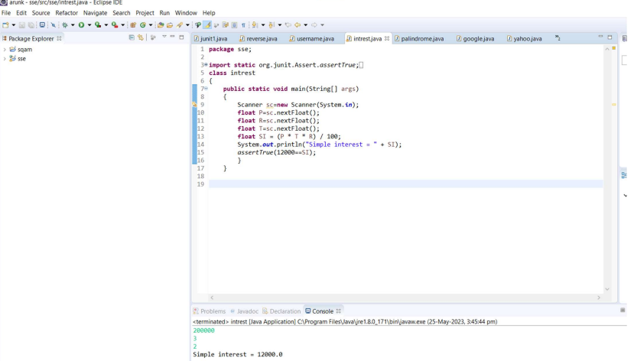

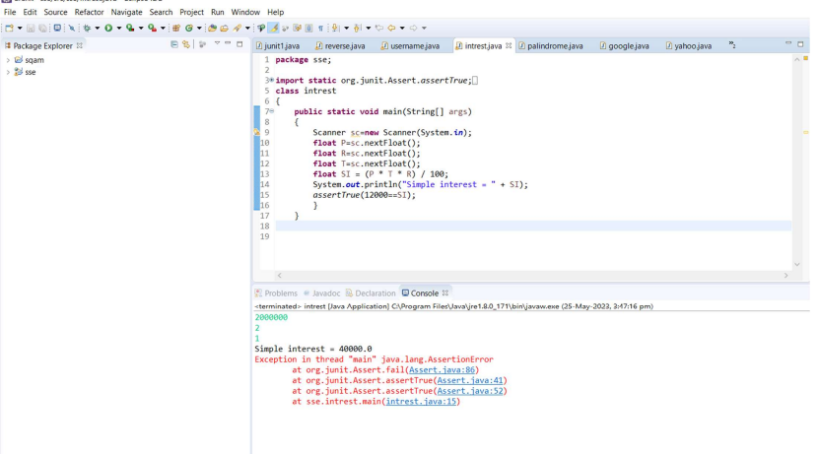

**RESULT:**

Hence the junit Testing Check Whether the Calculated simple interest is valid or not performed successfully.